ARJUN COLLEGE OF TECHNOLOGY

ASSIGNMENT-1

Naan Mudhalvan

Name: Manimaran.R

Reg no: 723920243027

Upload data set:

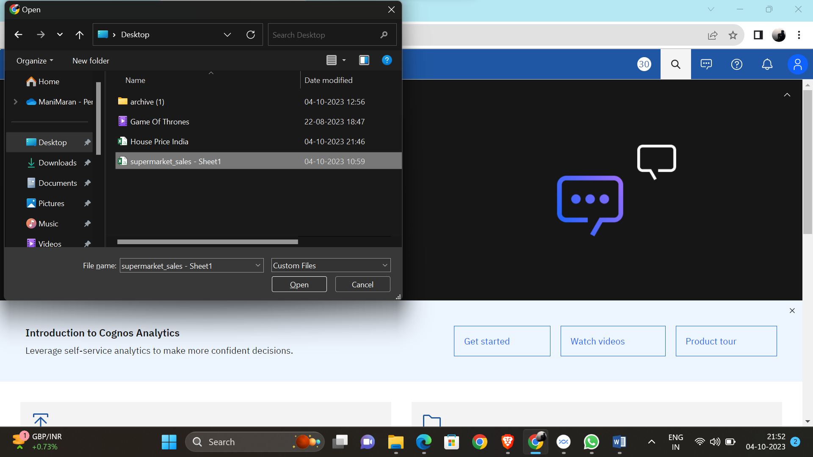

Data Module :

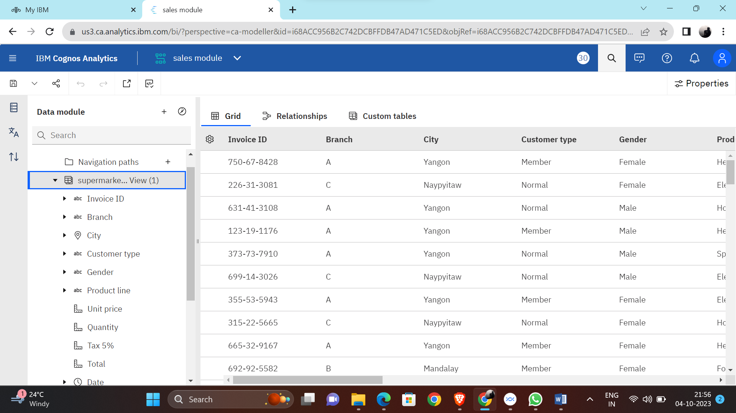

Exploration of Dataset:

